Activity 6.1: Octagon
You have been given a program that draws an octagon. The program contains a lot of blocks. You can reduce the number of blocks by identifying a pattern/repeated blocks and then using iteration.
Find the pattern and then use the ‘repeat’ block to reduce the number of blocks in the program.
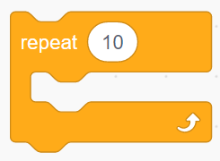
Don’t forget to screenshot your blocks and paste the screenshot into your evidence document.

Activity 6.1: Octagon
Can you work out how to amend your program to create a program that draws the shapes below using iteration?
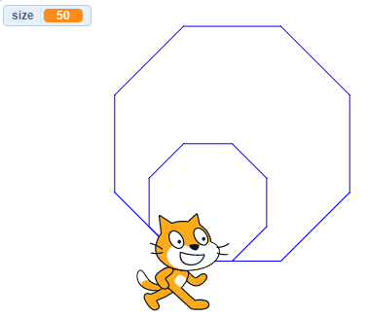
You should be able to do this by adding only three blocks!

HINTS
● You will need a variable to store the size of the shape. Set it to 100 at the start and change it to 50 after the first octagon has been drawn.
● You will need to put your original loop inside another loop that repeats twice.
● You will need to change move X steps to move variable steps.
Remember to screenshot your blocks and paste the screenshot into your evidence document.

